Experiment Result

-- MATLAB Simulation

**1. Sparse Graph VS Dense Graph:**

Use Maximum Likelihood Estimation:

A. Sparse Graph:

|  |  |  |  |  |  |  |
| --- | --- | --- | --- | --- | --- | --- |
|  | 100 Nodes Graph  (Overlay Node 40) | | | 10 Nodes Graph  (Overlay Node 6) | | |
| Number of Original Underlay Links | 174 | | | 12 | | |
| Number of Underlay Link Covered by Overlay Probing | 138 | | | 12 | | |
| Number of Chosen Overlay Node Pairs | 80 | 152 | 89 | 8 | 14 | 9 |
| Underlay Link Failure Probability | Random Distribution | Normal Distribution | Three-Classes | Random Distribution | Normal Distribution | Three-Classes |
| Correct Probability | 0.9819 | 0.9586 | 0.9998 | 0.9836 | 0.9207 | 0.9958 |
| False Positive Probability | 0.0076 | 0.0110 | <0.0001 | 0.0074 | 0.0380 | 0.0001 |
| False Negative Probability | 0.0105 | 0.0304 | 0.0001 | 0.0090 | 0.0413 | 0.0036 |

B. Dense Graph:

|  |  |  |  |  |  |  |
| --- | --- | --- | --- | --- | --- | --- |
|  | 100 Nodes Graph  (Overlay Node 40) | | | 10 Nodes Graph  (Overlay Node 6) | | |
| Number of Original Underlay Links | 400 | | | 40 | | |
| Number of Underlay Link Covered by Overlay Probing | 202 | | | 16 | | |
| Number of Chosen Overlay Node Pairs | 122 | 206 | 130 | 15 | 18 | 15 |
| Underlay Link Failure Probability | Random Distribution | Normal Distribution | Three-Classes | Random Distribution | Normal Distribution | Three-Classes |
| Correct Probability | 0.9775 | 0.9710 | 0.9996 | 0.9960 | 0.9794 | 1 |
| False Positive Probability | 0.0097 | 0.0080 | <0.0001 | 0.0019 | 0.0079 | 0 |
| False Negative Probability | 0.0127 | 0.0210 | 0.0004 | 0.0021 | 0.0127 | 0 |

**2. Comparison of Two Methods:**

A. Small Topology:

|  |  |  |  |  |  |  |
| --- | --- | --- | --- | --- | --- | --- |
|  | Maximum Likelihood Estimation | | | Bayesian Inference Model  (ɳ = 0.02) | | |
| Number of Original Underlay Links | 40 | | | | | |
| Number of Underlay Link Covered by Overlay Probing | 19 | | | | | |
| Number of Chosen Overlay Node Pairs | 17 | 20 | 17 | 17 | 20 | 17 |
| Underlay Link Failure Probability | Random Distribution | Normal Distribution | Three-Classes | Random Distribution | Normal Distribution | Three-Classes |
| Correct Probability | 0.9978 | 0.9938 | 1 | 0.9779 | 0.9724 | 1 |
| False Positive Probability | 0.0002 | 0.0002 | 0 | 0.0221 | 0.0273 | 0 |
| False Negative Probability | 0.0021 | 0.0060 | 0 | 0 | 0.0004 | 0 |

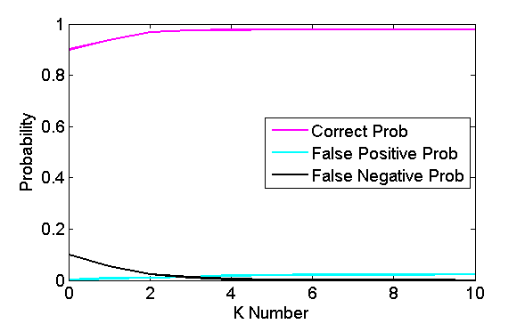

Random Distribution

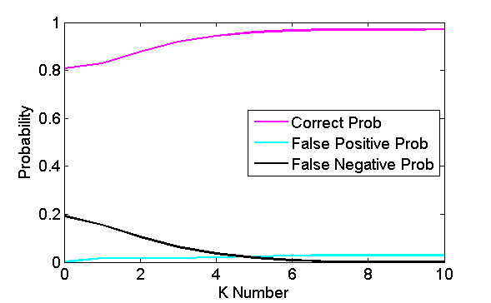

Normal Distribution

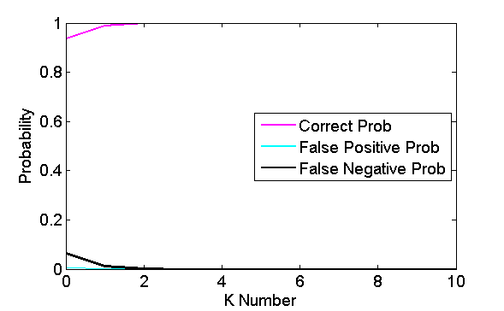

Three-Class Distribution

B. Large Topolgy:

|  |  |  |  |  |  |  |
| --- | --- | --- | --- | --- | --- | --- |
|  | Maximum Likelihood Estimation | | | Bayesian Inference Model  (ɳ = 0.02) | | |
| Number of Original Underlay Links | 400 | | | | | |
| Number of Underlay Link Covered by Overlay Probing | 197 | | | | | |
| Number of Chosen Overlay Node Pairs | 128 | 213 | 133 | 128 | 213 | 133 |
| Underlay Link Failure Probability | Random Distribution | Normal Distribution | Three-Classes | Random Distribution | Normal Distribution | Three-Classes |
| Correct Probability | 0.9855 | 0.9627 | 0.9991 | 0.9486 | 0.9026 | 0.9886 |
| False Positive Probability | 0.0057 | 0.0098 | 0.0001 | 0.0514 | 0.0955 | 0.0105 |
| False Negative Probability | 0.0088 | 0.0275 | 0.0008 | 0 | 0.0019 | 0.0009 |

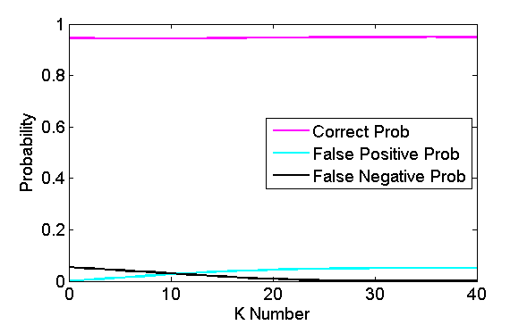

Random Distribution

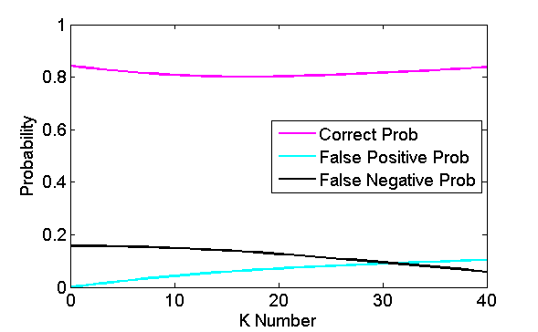

Normal Distribution

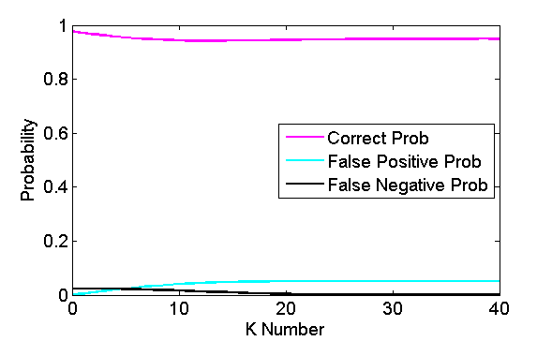

Three-class Distribution